Wise Words
Gary Wise
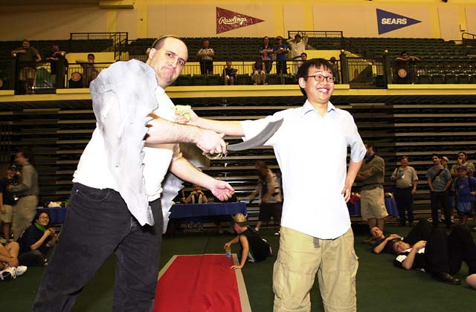
Gary Wise and Lan D. Ho participate in side events
I have some very fond memories of major events. Dallas was my first Pro Tour, Mainz was my first successful one, Worlds 2000 my first day three, NY 2000 teams my big win, but US Nationals is going to create a rivet in my mind unlike any of those.
I suppose a large part of the difference between US Nationals and those others comes from the fact that I wasn't playing. As a number of your emails have shown, a lot of people don't realize I'm Canadian and not American, and as a result, I was not allowed to participate in US Nats.
Being a competitive Canadian Magic player actually sucks a lot. Everyone else has a fragment of the DCI dedicated to serving their needs, be it the generic version that serves the Americans, or the European, Asian and Latin American branches that serve their regions. Canada gets lumped in with the States far too often, and as a result, Canadians get called Americans as often as Japanese get called Chinese.
Along with this lost identity and lack of DCI attention comes realization of money lost. Simply, Americans have a large cash purse nationals while Europeans, South Americans and Asians each have their big money Continental Championships while Canada has a $8000 total prize purse National Championships with no Continental championships to go to. In other words, if you make Top 4 in Canadian Nationals, you barely make your travel money back.
On top of that, this year Canadian Nationals falls on the weekend of July 21-22. In other words, the tournament ends seventeen days before World Championships. If I were to qualify for Worlds at that tournament, I'd be pretty angry about the fact I'd only have that long to a) playtest an entirely new Extended format and b) have that long to decide to either build an entirely new Standard deck based off the metagame established at Canadian Nats for Worlds or play the deck that won me that tournament knowing full well that every one of my eventual Standard format opponents will have constructed their deck based Canadian Nationals Top 8 Decks. Neither option seems super.
While all that may seem unfair (the late date of nationals occurred because of a lack of suitable tournament space on an earlier date), it is with this jaded view that I made my way to US Nationals, fully expectant of a weekend full of jealousy in watching America's finest compete for a lot more money than Canada's finest ever would. Instead, when all was said and done, I emerged from Disney's Wide World of Sports a little less jaded and a little happier with the state of the game, because it felt to me like head judge Collin Jackson, Tournament Manager Jeff Donais and the entirety of Organized Play took a stand during this tournament, pronouncing far and wide "WE AREN'T GOING TO TAKE THIS ANYMORE."

Everyone and their little sister seems to have questions about what happened in Brian Hegstad's two big matches-the first in the final round of the swiss against Pete Leiher, the second in the quarter-finals against Casey McCarrel-where speculated sketchiness ensued, and while nothing should be taken away from Hegstad (seeing as to how he'd played well enough to position himself near the top of the standings), who likely would have won both matches were time limits and deck stacking not an issue, it is the actions of Leiher and McCarrel that I'll focus on here.
Thanks to Pete Leiher, the reading off of the Top 8 going into Day 3 of US Nats was the most exciting I've ever listened to. After forty-five minutes of nail biting and bickering, debate and conjecture, it was decided that in his match with Hegstad, the warning Pete had incurred by trying to cast a Hull Breach as an instant after five rounds of Standard play and who knows how much play testing wasn't severe enough, as the time the move ate up eventually would go to cost Brian the one extra turn he needed to win the match. To bluntly say that Pete out and out stalled would be wrong as one never knows the exacts of what is going through a player's mind, but when he took a few more minutes to decide how to use the two mana he had floating after the illegal Breach attempt, more minutes to decide whether or not to Breach an unimportant Tsabo's Web and more minutes still to decide whether or not to play a land each turn (he drew a lot of them), one could infer that things weren't on the up and up.
With this in mind, Collin Jackson made what may eventually be a very important ruling: Despite the match having ended, the complaints of Hegstad and the many spectators were valid enough that the Head Judge felt the claim that Leiher had been stalling was worth taking a look at. Interviewing just about anyone who had seen the match, Colin finally set a precedent by changing the penalty Pete had incurred during the match after it was over, altering the result. Anything that brings us closer to the eradication of cheating in Magic is a good thing.
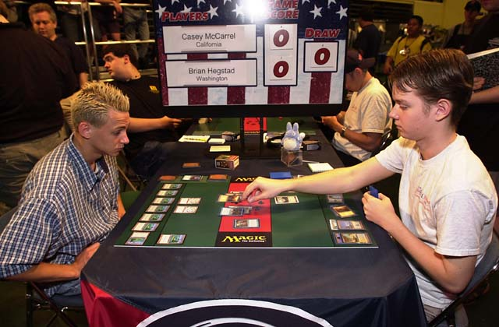
As for Casey, we don't need to be careful about what is said because frankly, he got caught. I have to say I don't know Casey that well (not too surprisingly, we hang with different crowds), but it's really too bad. For those of you out there thinking about a rise to the top, a la Casey, keep in mind that any time you win through cheating in a money tournament, you are literally stealing not only from the player you cheated, but also from every person who falls a spot in the rankings as a result of your success. Cheaters are acting with criminal intent. Even more unfortunately, as they read this, they're probably laughing at what they perceive to be moralistic tripe.
Casey, who you probably know has been caught once before, served a six month suspension that cost him a spot in the Invitational and almost made him quit the game after PT London. So this time one has to expect that he'll have the book thrown at him. I overheard a couple of people speculating that his suspension would be at around thirty months, and while I think it might be a little less than that (my somewhat random guess is around 18 months). What's important is that the message should be sent to the cheaters out there that this wouldn't be tolerated.
What Casey actually did, for those of you who don't know, was stack his opponent's deck while shuffling. How many times Casey used this tactic is unknown, but a number of players did complain to officials afterwards, saying 'he did that to me too!' in exasperation. Mike Turian pointed out in his tournament report on Mindripper.com, that in every one of Casey's feature matches, Casey's opponent's mulliganed, so it seems more likely than not that he was doing it all through the tournament. Thus removing deserving players from atop the standings. I can only hope that his punishment will cure the Pro Tour of any player ever doing anything like this again.
Now, a few odds and ends:
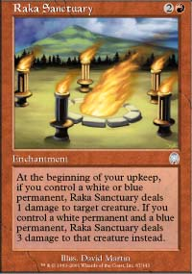
1) I know how Raka Sanctuary works. A number of you took it upon yourselves to email me explaining how this card is worded, failing to recognize that I was speaking in implication, not fact. Yes. The Sanctuary CAN target your own creatures, but by the time you have to do that you should have won the game. If somehow your opponent manages to survive, you should still be able to stop the Sanctuary with either a four-toughness creature. Don't go thinking that the Sanctuary can't target your creatures, but as you always choose the target, its seldom it ever will.
2) I am going to start working on my Apocalypse Limited review this week. A number of you have been emailing me asking for tips on the set, and all those questions will be answered in there. With my testing for Worlds, however, I haven't had an opportunity to work on Team Rochester with Apocalypse, so I don't really have any information for you there.
3) If you are a player with 10 or more PT points since last year's New York who is looking for a team, let me know at JgaryWise@yahoo.com. A number of people have come to me with two-man teams looking for a third. So I will use this column to play matchmaker for the bunch of you. 50 Points is a lot for three people to muster.
4) I've received a couple of emails asking me to take a look at Meddling Mage the same way Warren Marsh and I did to Fact or Fiction a few weeks ago. Like Fact or Fiction, the way you should use Meddling Mage depends largely on the situation your game is, but more than FoF, the Mage is a card that gets better the more you prepare for the tournament.
In Limited play, the Mage mostly serves as a 2/2 for two mana, but you can use its ability to your advantage. Obviously, in Rochester Draft, you'll know the most powerful cards in any given opponent's deck, so when you cast the Mage (or Pikula, as some people call it after its creator), you can name off the power card you're most afraid of in your opponent's deck. In Booster Draft, you can use the information at your disposal, namely the cards you saw in the first game, and the combination of the colors your opponent is playing and the cards you passed in those colors to make an educated guess about your opponent's deck. In other words, if your opponent is playing a green-red-white deck and you passed them Rith, the Awakener, it's very likely that card is in their deck, and the Mage can be a way for you to stop it.
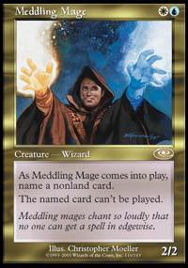
In Constructed, knowing what card to name should be pretty easy if you have done your homework. If you pay attention to the trends in any given environment, you'll know the generic deck lists of any given archetype, and you can play Pikula accordingly.
If, for example, you are playing a Counter Rebel deck against a blue-white control deck in pre-Apocalypse Standard, when you cast your second turn Mage, you have to ask yourself what's important at the time. If you've cast a first turn Sergeant, then you've got your creatures into play and can start searching for more, so naming Wrath of God, a card the blue-white deck is most likely to use in order to control creature decks, makes the most sense. However, if you fear your opponent's ability to kill a third turn Lin Sivvi as your first and only searcher while you hold a fistful of countermagic, you may want to name Last Breath, one of the few plausible low-cost creature kill spells that your opponent could have, as you can use your countermagic to stop Wraths being cast later on. It's not often that you'll want to do this, but you should always consider your options before acting.
What this all means is that with Meddling Mage as with the game itself, knowledge is power. Do your research and know the decks people are playing and you'll know which weaknesses of your deck the Mage should be addressing. Hopefully, with that said, this week's Wise Words has empowered you a little. If you have any specific questions about this week's column (by the way, I say specific because I just don't have the time to really answer a question like "how do I get better at draft?" fully. Sorry guys), let me hear them at JgaryWise@yahoo.com. It may take me a while, but I'll get to your question eventually. That's it for now, have a good week.

